**SRS DOCUMENT**

**ONLINE BANKING PROJECT**

**Introduction**

Online Banking enables customers to access their accounts and get information of their accounts and different products and services provided by the bank without actually visiting the bank.

In our project some customers are provided with a User ID and Password and others can register while opening an account. The customer can login with these details and he/she can access their various accounts and can also update or view their profile. The customer can also view balance in their accounts and make withdraws, deposit or pay EMI.

Customers can enquire about an account and also about the interest on the account.

**Implementation**

In this project we will be accomplishing the following tasks:

1. User Login / Registration
2. Viewing / Updating customer / employee information
3. Employee Login
4. Account creation( opening ) / deletion (closing)
5. Account access for different types of accounts (Savings, checking, Loan)
6. Access to Account, Customer and Employee Logs
   * Account and Customer logs (By employees only)
   * Employee Logs (Bank Admin/Owner login only)
7. Transactions (like Withdraw, Deposit, Pay EMI, Wire Transfer)

**Database Tables**

|  |  |
| --- | --- |
| **Table%20images/Customer%20Table.jpeg** | **PRIMARY KEY :**  CustID |
| **Table%20images/Account%20Checking.jpeg** | **FOREIGN KEY:** AccNumber  **ON TABLE:** Accounts |
| **Table%20images/Accounts.jpeg** | **PRIMARY KEY :**  AccountNumber  **FOREIGN KEY:** Cust_ID  **ON TABLE:** Customers |
| **Table%20images/Account%20Status.jpeg** | **FOREIGN KEY:** AccountNumber  **ON TABLE:** Accounts |
| Table%20images/Account%20Savings.jpeg | **FOREIGN KEY:** Account_Number  **ON TABLE:** Accounts |
| Table%20images/Account%20Loan.jpeg | **FOREIGN KEY:** ACC_NUM  **ON TABLE:** Accounts |
| **Table%20images/Employee%20Stat.jpeg** | **FOREIGN KEY:** EmpID  **ON TABLE:** Employee |
| Table%20images/Account%20Log.jpeg | **NA** |
| **Table%20images/Customer%20Status.jpeg** | **FOREIGN KEY:** CustID  **ON TABLE:** Customer |
| **Table%20images/Employee%20log.jpeg** | **NA** |
| **Table%20images/Employee.jpeg** | **PRIMARY KEY :**  EmpID |
| **Table%20images/Cust%20log.jpeg** | **NA** |

**E-R Diagram**

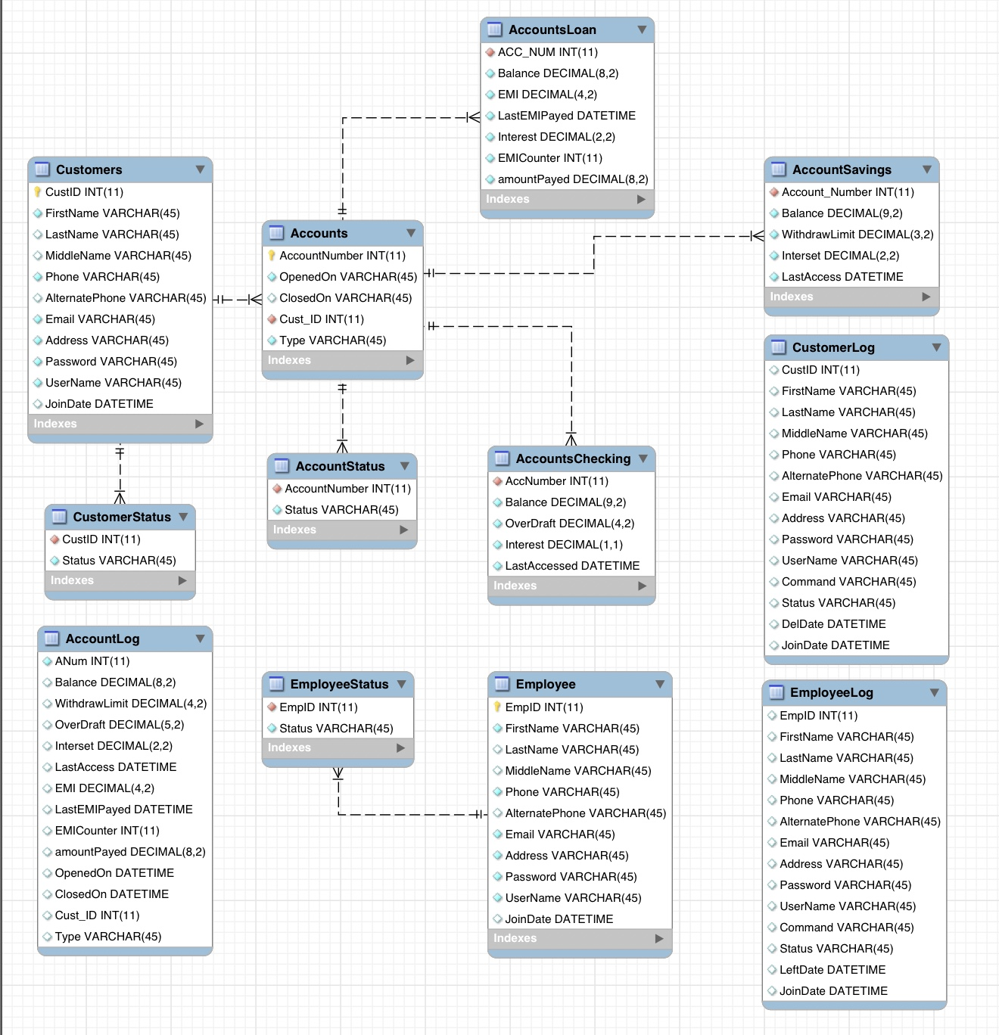

**Use Case Diagram**

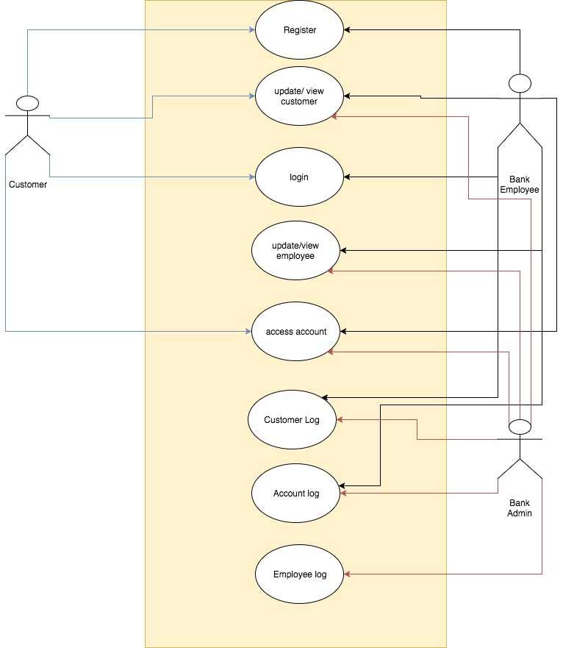

We will have 3 primary actors for this project

1. **Admin / Bank Owner:**

Acting upon :

Create, view, update, delete customer / employee

Access all accounts

View logs for Accounts, Customers and Employees

1. **Bank Employee**

Acting upon :

Create, view, update customer

Access all accounts

View logs for Accounts and Customers

1. **Bank Customer**

Acting upon :

Create, view, update, delete customer

Access their accounts

**HIGH LEVEL DATA FLOW DIAGRAM**

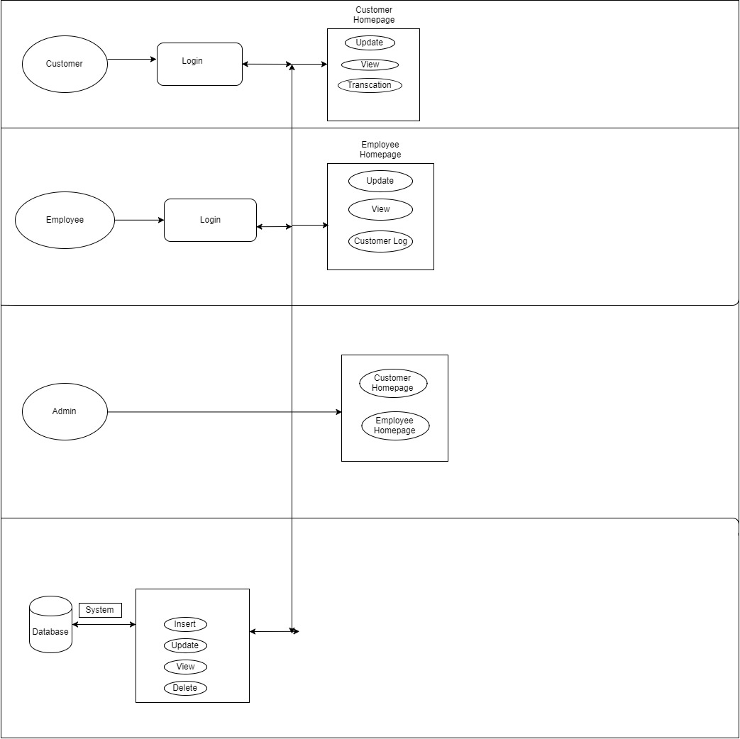

**USER INTERFACE**

